**Sales(Task 1 to 4):-**

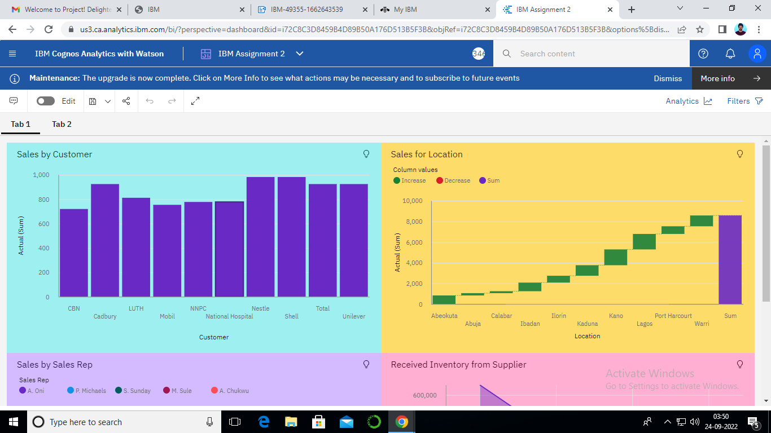

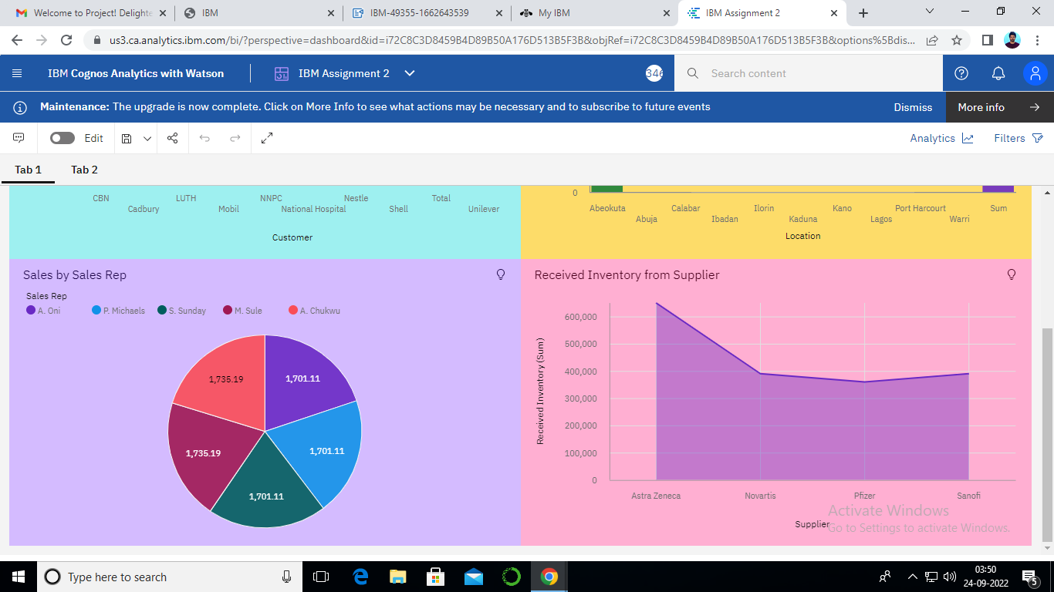

https://us3.ca.analytics.ibm.com/bi/?perspective=dashboard&pathRef=.my_folders%2FIBM%2BAssignment%2B2&action=view&mode=dashboard&subView=model000001836eaaea9e_00000002

**Inventory(Task 5 to 8):-**

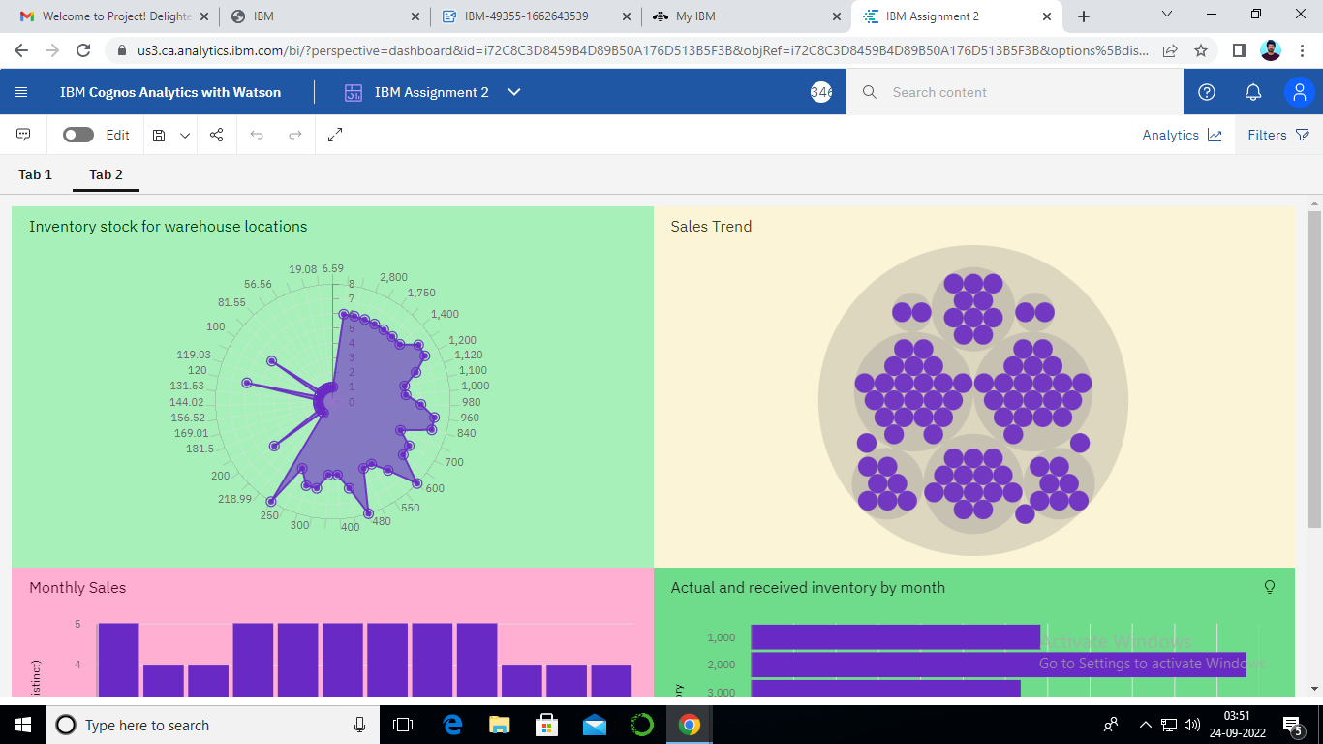

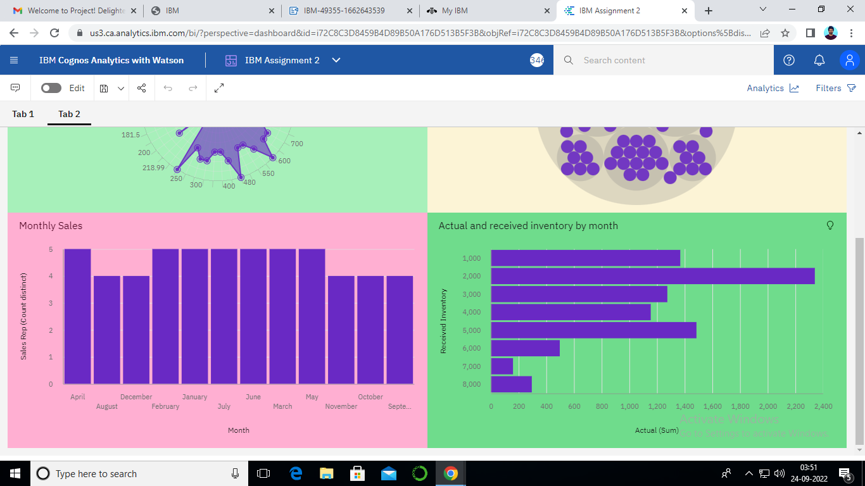

**https://us3.ca.analytics.ibm.com/bi/?perspective=dashboard&pathRef=.my_folders%2FIBM%2BAssignment%2B2&action=view&mode=dashboard&subView=model000001836eb30033_00000000**